Ten Prophetic Clues Concerning
Levi – the Welsh

At the division of Solomon’s kingdom into Two-tribed Judah and Ten-tribed Israel, a large part of the tribe of Levi settled in Judah. Allmost all of the priests, the cohanim, were there, because the Temple of God was in Jerusalem. And the 13 cities of the priests were in Benjamin-Judah (Jos 21:4). Many other Levites will also have gone south to serve as gatekeepers, priest-assistants and singers. We find the cohanim and the Levites in Judaism (ca. 8% of the Jews). Jewish graves bear emblems such as blessing hands for priests and jugs for Levites.
Yet 35 Levite cities remained in Ten-tribed Israel. And the ancestral possessions were not easily given up. During the Assyrian captivity, many northern Levites must have gone with the Ten Tribes, to end up in Northwestern Europe as well.
There is not much direct history connecting the tribe of Levi to the Welsh people. Even the Caucasian population of Wales comes from various backgrounds. One can compare this to Jewry. The Jewish people have known many proselytes, yet, there has been a core of the tribe of Judah (and some of Levi & Benjamin) over the past 2500 years. The core passes on characteristics and genes to the periphery. Looking at the ‘prophetic clues’, one has to conclude, that a core of the tribe of Levi once found its way to Wales. This core passed its characteristics and genes onto the influx of others. The more fulfilled prophetic clues we find, the stronger our case. What follows is not historic proof, but proof by revelation.

1st Clue: Levi: scattered

5 Simeon and Levi are brothers; weapons of violence are their swords. 6 O my soul, come not into their council; O my spirit, be not joined to their company; for in their anger they slay men, and in their wantonness they hamstring oxen. 7 Cursed be their anger, for it is fierce; and their wrath, for it is cruel! I WILL DIVIDE THEM IN JACOB AND SCATTER THEM IN ISRAEL (Genesis 49:5-7, RSV throughout).

The Levites were scattered througout Israel because of their Levitical cities and ended up in both Judah and Israel.

Some Welsh migrated to Cornwall and Brittany in the 5th - 6th centuries. And in later centuries many Welsh emigrated to other areas of the world. The Welsh are scattered, just like Levi.

The Welsh according to Wikipedia:

Wales 2 million^{[1]}
(identify as Welsh)

United States | 2 million^{[2]}
England | 610,000^{[3]}
Canada | 475,000 (Includes those of mixed ancestry)^{[4]}
Australia | 126,000^{[5]}
Argentina | 50,000^{[6]}
Scotland | 17,000^{[7]}
New Zealand | 10,000^{[8]}

2nd Clue: Levi: priests & druids

And Moses said to Korah, "HEAR NOW, YOU SONS OF LEVI: 9 is it too small a thing for you that the God of Israel has separated you from the congregation of Israel, to bring you near to himself, to do service in the tabernacle of the LORD, and to stand before the congregation to minister to them; 10 and that he has brought you near him, and all your brethren the sons of Levi with you? AND WOULD YOU SEEK THE PRIESTHOOD ALSO? 11 Therefore it is against the LORD that you and all your company have gathered together ...” (Numbers 16:8-11).
Then Micah said, "Now I know that the LORD will prosper me, BECAUSE I HAVE A LEVITE AS PRIEST." (Judges 17:13).
And the Danites set up the graven image for themselves; and Jonathan the son of Gershom, son of Moses, AND HIS SONS WERE PRIESTS TO THE TRIBE OF THE DANITES until the day of the captivity of the land. (Judges 18:30).

Levites as priests

Moses was a Levite, a descendant of Levi, and also functioned as a special priest, while he was not a descendant of Aaron. He offered the dedicatory offerings of Aaron and his sons.
Korah and his band coveted the priesthood while they were already Levites.
And Jonathan the Levite was a descendant of Moses, and became a priest of the tribe of Dan.

Priests - Druids

What the priests and prophets are to Israel, the Druids were to the Celts. In the past I wrote about priests and druids:
“-the training as a priest/druid was very long;
-priests/druids were exempt from tax and conscription;
-priests/druids served many gods (that's why the Israelites were removed from the land!);
-priests/druids believed in a final judgment by fire;
-priests/druids worshipped the sun (the sun god);
-priests worshipped Ba'al & Bel & Molekh and other gods and the druids worshipped Bel & Belenos & Lug(k) [maybe Mo-Lekh is the same as Lug] and other gods;
-Israelites made human sacrifices and so did the Celts/druids;
-druids/priests were imposing figures in white, with long beards;
-priests/druids could impose their will on the people, even stop fighting tribes and force them to return.”

Druids in Wales

https://britishheritage.com/history/history-druids-britain:
“Druidism, in fact, traces its origins to ancient Wales, where the order began long before the advent of written history. Druids were the priests of the early Celtic religion, on the top rung of the three-tiered Celtic society consisting of serfs, warriors, and learned men. But in addition to their religious function, Druids also performed the roles of judge, doctor, and scholar. They were educated through a long and grueling process of rote memorization. Druidic law forbade its followers to write down any of the religious teachings, a rule that has unfortunately prevented us from having firsthand knowledge of their Celtic religion.

What historical records we do have of the Druids come to us from non-objective sources ... In these records, the writers all remark upon the Druids' extensive knowledge, particularly in the fields of mathematics, astronomy, and physics.

But in addition to their learning, early historians also took note of what they considered to be the Druids' barbaric religious practices. In particular, they were appalled by the use of human sacrifice. The Romans reported that victims were tied to wicker effigies and burned alive, a report substantiated by archaeological remains. Further evidence has been found of 'triple deaths' where a victim was simultaneously stoned, drowned, and impaled on a spear.

Often, sacrifice involved a spiritual trade of sorts, sacrificing a less prominent member of society so that someone more important might survive.”

3rd Clue: Levi: piety & revival

Then Moses stood in the gate of the camp, and said, "WHO IS ON THE LORD’S SIDE? Come to me." AND ALL THE SONS OF LEVI GATHERED THEMSELVES together to him. 27 And he said to them, "Thus says the LORD God of Israel, ‘Put every man his sword on his side ... and slay every man his brother ... .’" 28 And the sons of Levi did according to the word of Moses ... 29 And Moses said, "TODAY YOU HAVE ORDAINED YOURSELVES FOR THE SERVICE OF THE LORD, ... ." (Ex 32:26-29).
[At Hezekiah’s reform:] But the priests were too few and could not flay all the burnt offerings, so until other priests had sanctified themselves THEIR BRETHREN THE LEVITES HELPED THEM, until the work was finished — FOR THE LEVITES WERE MORE UPRIGHT IN HEART THAN THE PRIESTS IN SANCTIFYING THEMSELVES. (2Chron 29:34).
And Nehemiah … and Ezra the priest and scribe, and THE LEVITES WHO TAUGHT THE PEOPLE said to all the people, "This day is holy to the LORD your God; do not mourn or weep." … SO THE LEVITES STILLED ALL THE PEOPLE, saying, "Be quiet, for this day is holy; do not be grieved." (Nehemiah 9:9-11).

Piety of Levi(tes)

The first example of Levite piety is the "Levite" Moses. God used him to make His Law known to Israel. Moses says in Psalm 90:17, “Let the favor of the Lord our God be upon us, and establish thou the work of our hands upon us, yea, the work of our hands establish thou it.”
The tribe of Levi was the only tribe not to participate in the worship of the Golden Calf.
Forty years later Phinehas was incensed at the idolatry of the Israelites in the plains of Moab.
The Levites played a central role in the reforms of Hezekiah, Josiah, Zerubbabel & Joshua and Ezra & Nehemiah.
There have been a great piety and many revivals in Wales. One of these revivals went around the world.

The Welsh Methodist Revival

Wikipedia: “The Welsh Methodist revival was an evangelical revival that revitalised Christianity in Wales during the 18th century. Methodist preachers such as Daniel Rowland, William Williams and Howell Harris were heavily influential in the movement. The revival led eventually to the establishment of the Welsh Calvinistic Methodists as a denomination (now more commonly known as the Presbyterian Church of Wales) and it also revitalised older dissenting churches.”

The Welsh Revival of 1904-1905

Wikipedia: “The 1904–1905 Welsh revival was the largest Christian revival in Wales during the 20th century. It was one of the most dramatic in terms of its effect on the population, and triggered revivals in several other countries. The movement kept the churches of Wales filled for many years to come, seats being placed in the aisles in Mount Pleasant Baptist Church in Swansea for twenty years or so, for example. Meanwhile, the Awakening swept the rest of Britain, Scandinavia, parts of Europe, North America, the mission fields of India and the Orient, Africa and Latin America. The Welsh revival has been traced as the root of the megachurches in the present era.”

4th Clue: Levi: choirs and music

These are the [Levites] whom David put in charge of THE SERVICE OF SONG in the house of the LORD, after the ark rested there. 32 THEY MINISTERED WITH SONG before the tabernacle of the tent of meeting, until Solomon had built the house of the LORD in Jerusalem; and they performed their service in due order. 33 These are the men who served and their sons. Of the sons of the KOHATHITES: HEMAN THE SINGER ... 39 and his brother ASAPH, who stood on his right hand, ... On the left hand were their brethren the sons of Merari: ETHAN ... (1Chronicles 6).
And the LEVITES: Jeshua, Binnui, Kadmiel, Sherebiah, Judah, and Mattaniah, WHO WITH HIS BRETHREN WAS IN CHARGE OF THE SONGS OF THANKSGIVING (Neh 12:8).
David also commanded the chiefs of the Levites TO APPOINT THEIR BRETHREN AS THE SINGERS who should play loudly on musical instruments, on harps and lyres and cymbals, to raise sounds of joy. 17 So the Levites appointed HEMAN ... and of his brethren ASAPH ... and ETHAN ... 19 THE SINGERS, HEMAN, ASAPH, AND ETHAN, were to sound bronze cymbals; ... 22 Chenaniah, leader of the Levites in music, should direct the music, for he understood it (1Chronicles 15).

Levitical Choirs

Once the temple was built and the tabernacle no longer had to be carried around, the Levites were given other tasks. One of those tasks was that they formed choirs and provided the music. King David had put them in different choirs. Well-known singers were Heman, Asaph and Ethan.
There are also at least 25 psalms by Levites in the Bible. Of the Korahites 10 psalms (Ps 42, 44-49, 84,85), and of Asaph 12 psalms (Ps 50, 73-83). Psalm 88 is from Heman the singer, Psalm 89 by Ethan and Psalm 90 by Moses.

Music of Wales

Wikipedia: “The Music of Wales (Welsh: Cerddoriaeth Cymru), particularly singing, is a significant part of Welsh national identity, and the country is traditionally referred to as "the land of song". This is a modern stereotype based on 19th century conceptions of Nonconformist choral music and 20th century male voice choirs, Eisteddfodau and arena singing, such as sporting events, but Wales has a history of music that has been used as a primary form of communication. ...
Music in Wales is often connected with male voice choirs, such as the Morriston Orpheus Choir, Cardiff Arms Park Male Choir and Treorchy Male Voice Choir, and enjoys a worldwide reputation in this field. This tradition of choral singing has been expressed through sporting events, especially in the country's national sport of rugby, which in 1905 saw the first singing of a national anthem, Wales's Hen Wlad Fy Nhadau, at the start of an international sporting encounter. ...
Welsh traditional music declined with the rise of Nonconformist religion in the 18th century, which emphasized choral singing over instruments, and religious over secular uses of music; traditional musical styles became associated with drunkenness and immorality. The development of hymn singing in Wales is closely tied with the Welsh Methodist revival of the late 18th century. The hymns were popularised by writers such as William Williams, while others were set to popular secular tunes or adopted Welsh ballad tunes.”
There are many famous Welsh singers like: Tom Jones, Duffy, Bryn Terfel, Charlotte Church, Geraint Llewellyn Evans, Aled Jones, Shirley Bassey, Katherine Jenkins.

5th Clue: Levi: coal

"AARON shall present the bull as a sin offering for himself, and shall make atonement for himself and for his house; he shall kill the bull as a sin offering for himself. 12 And he shall TAKE A CENSER FULL OF COALS OF FIRE FROM THE ALTAR before the LORD, and two handfuls of sweet incense beaten small; and he shall bring it within the veil (Leviticus 16:11-12).
Then flew one of the seraphim to me, HAVING IN HIS HAND A BURNING COAL which he had taken with tongs from the altar (Isaiah 6:6).
Coal, fire & ashes

The priests and the Levites had the task of caring for the altar, for the fire that was never to go out, for the wood, the coals and the ashes. We don't know if the Hebrews had coal, although it was found in Syria at the time. The coal the Levites and priests worked with was most likely charcoal. Still, we want to put coal here as a clue between Levi and Wales.

Coal industry in Wales

Wikipedia: “The coal industry in Wales has played an important role in the Industrial Revolution. Coal mining in Wales expanded in the eighteenth century to provide fuel for the blast furnaces of the iron and copper industries that were expanding in southern Wales. The industry had reached large proportions by the end of that century, and then further expanded to supply steam-coal for the steam vessels that were beginning to trade around the world. The Cardiff Coal Exchange set the world price for steam-coal and Cardiff became a major coal-exporting port. The South Wales Coalfield was at its peak in 1913 and was one of the largest coalfields in the world. It remained the largest coalfield in Britain until 1925. The supply of coal dwindled, and pits closed in spite of a UK-wide strike against closures. The last deep mine in Wales, Tower Colliery, closed in 2008, after thirteen years as a co-operative owned by its miners.
The South Wales Coalfield was not the only coal mining area of the country. There was a sizeable industry in Flintshire and Denbighshire in northeast Wales, and coal was also mined in Anglesey.”

6th Clue: Levi: gatekeepers

Of the Levites: ... 17 The gatekeepers were: Shallum, Akkub, Talmon, Ahiman, and their kinsmen (Shallum being the chief), 18 stationed hitherto in the king’s gate on the east side. These were the gatekeepers of the camp of the Levites. 19 Shallum the son of Kore, son of Ebiasaph, son of Korah, and his kinsmen of his fathers’ house, the Korahites, were in charge of the work of the service, keepers of the thresholds of the tent, as their fathers had been in charge of the camp of the LORD, keepers of the entrance ... 22 All these, who were chosen as gatekeepers at the thresholds, were two hundred and twelve. ... 23 So they and their sons were in charge of the gates of the house of the LORD, that is, the house of the tent, as guards ... 26 for the four chief gatekeepers, who were Levites, were in charge of the chambers and the treasures of the house of God. 27 And they lodged round about the house of God; for upon them lay the duty of watching, and they had charge of opening it every morning. (1Chronicles 9:14-27).

Gatekeepers

The Levites were priest assistants, singers, and gatekeepers. Levi and the tribe of Levi have a thing with the sword. The patriarch Levi murdered the people of Shechem with his brother Simeon in revenge for the rape of Dinah. After the Golden Calf incident, the Levites went through the tribes with the sword. Phinehas slew the adulterous Israelite and the Midianite woman with a spear. The swords of the priests became knives in the sacrificial service. And the armed gatekeepers were Levites. Also in the time of the Maccabees Levi had the sword. Mattathias and his five sons were of the tribe of Levi, they were priests.

The Tudors from Wales

The Tudor dynasty formed the kingship of England and Wales from 1485 to 1603. The Tudors also ruled Ireland from 1541 to 1603.
The Tudors changed England into a renaissance nation. The Tudor era was a huge boom for English culture, including literature, science, architecture and commerce. The Tudors also strengthened the English fleet and the base for the British colonial empire. The ancestor of the house, Owen Tudor (c. 1400-1461), was a Welsh soldier who first became steward and later husband of Catherine of Valois, widow of King Henry V of England

Prime minister Lloyd George

The (Welsh) Lloyd George was Prime Minister from 1916 to 1922. During his premiership, the British Empire lost nearly 1 million men during the Great War (WW I). He was, as it were, a watchman over the British Empire. It is the war with the most deaths for the British to date.

Welsh Guards

Wikipedia: “The Welsh Guards (WG; Welsh: Gwarchodlu Cymreig), part of the Guards Division, is one of the Foot Guards regiments of the British Army. It was founded in 1915 as a single-battalion regiment, during the First World War, by Royal Warrant of George V. Shortly after the regiment's formation, it was deployed to France where it took part in the fighting on the Western Front until the end of the war in November 1918. During the inter-war years, the regiment undertook garrison duties in the United Kingdom, except 1929–1930 when it deployed to Egypt, and late 1939 when it deployed to Gibraltar.”

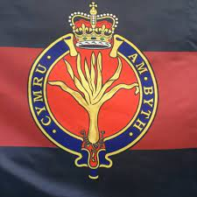
1st Batallion Welsh Guards

7th Clue: Levi: prose & poetry (eisteddfod)

When Moses had finished WRITING THE WORDS OF THIS LAW IN A BOOK, to the very end (Deuteronomy 31:24).
So MOSES WROTE THIS SONG the same day, and taught it to the people of Israel (Deuteronomy 31:22).
Then MIRIAM, the prophetess, the sister of Aaron, TOOK A TIMBREL IN HER HAND; and all the women went out after her with timbrels and dancing (Ex 15:20).
This is a copy of the letter which King Artaxerxes gave to EZRA THE PRIEST, THE SCRIBE, learned in matters of the commandments of the LORD and his statutes for Israel (Ezra 7:11).
TO THE CHOIRMASTER. A MASKIL OF THE SONS OF KORAH. As a hart longs for flowing streams, so longs my soul for thee, O God (Psalm 42:1).
The singers, HEMAN, ASAPH, AND ETHAN, WERE TO SOUND BRONZE CYMBALS (1Chron 15:19).

Bible & Levi

Large parts of the Bible have been written by the tribe of Levi. The first five books are by Moses; 1 and 2 Chronicles and Ezra belong to Ezra the priest; at least 28 psalms are by Levi; Jeremiah the priest wrote two books, and Ezekiel the priest wrote his book.
Christipedia on the Levites and the Temple Service: “The Levites were appointed over 'the service of song'; the songleading was assigned to them; others became doorkeepers; some were singers and others played various instruments in public worship, 1Ch 6:31; 1Ch 15:16, 26. David divided the 38,000 Levites in his day (1Ch 23:3) into four classes, according to their appointed service.”
Thus the tribe of Levi was adept at prose, poetry and singing.

Eisteddfod

Wikipedia: “In Welsh culture, an eisteddfod is a festival with several ranked competitions, including in poetry and music. The term eisteddfod, which is formed from the Welsh morphemes: eistedd, meaning 'sit', and fod, meaning 'be', means, according to Hywel Teifi Edwards, "sitting-together." Edwards further defines the earliest form of the eisteddfod as a competitive meeting between bards and minstrels, in which the winner was chosen by a noble or royal patron.
The first documented instance of such a literary festival and competition took place under the patronage of Prince Rhys ap Gruffudd of the House of Dinefwr at Cardigan Castle in 1176. However, with the loss of Welsh independence at the hands of King Edward I, the closing of the bardic schools, and the Anglicization of the Welsh nobility, it fell into abeyance. The current format owes much to an 18th-century revival, first patronized and overseen by the London-based Gwyneddigion Society. It was later co-opted by the Gorsedd Cymru, a secret society of poets, writers, and musicians founded by Iolo Morganwg, whose beliefs were "a compound of Christianity and Druidism, Philosophy and Mysticism."
Despite the Druidic influences and the demonstrably fictitious nature of Iolo Morganwg's doctrines, rituals, and ceremonies, both the Gorsedd and the eisteddfod revival were embraced and spread widely by Anglican and nonconformist clergy. The revival therefore proved enormously successful and is credited as one of the primary reasons for the continued survival of the Welsh language, Welsh literature, and Welsh culture after more than eight centuries of colonialism.”

8th Clue: Levi: insurrection

And the LORD sent a plague upon the people, because they made THE CALF WHICH AARON MADE (Ex 32:35).
MIRIAM AND AARON SPOKE AGAINST MOSES because of the Cushite woman whom he had married, for he had married a Cushite woman; and they said, "Has the LORD indeed spoken only through Moses? Has he not spoken through us also?" And the LORD heard it (numbers 12:1-2).
And Moses said to Korah, "Hear now, you sons of Levi: 9 is it too small a thing for you that the God of Israel has separated you from the congregation of Israel, to bring you near to himself, to do service in the tabernacle of the LORD ... and all your brethren the sons of Levi with you? And would you seek the priesthood also? 11 THEREFORE IT IS AGAINST THE LORD THAT YOU AND ALL YOUR COMPANY HAVE GATHERED TOGETHER; what is Aaron that you murmur against him?" (Numbers 16:8-11).

Strikes

Wikipedia: “The Welsh coal strike of 1898 was an industrial dispute involving the colliers of South Wales and Monmouthshire. The strike began as an attempt by the colliers to remove the sliding scale, which determined their wage based on the price of coal. The strike quickly turned into a disastrous lockout which would last for six months and result in a failure for the colliers as the sliding scale stayed in place. The strike is seen as an important landmark in Welsh history as it saw the true adoption of trade unionism in the southern coalfield which had been slow to take hold before then. The South Wales Miners' Federation was the largest trade union to have originated from this dispute.”

Rhondda-rellen

Wikipedia: “The Miners Strike of 1910-11 was an attempt by miners and their families to improve wages and living conditions in severely deprived parts of South Wales, where wages had been kept deliberately low for many years by a cartel of mine owners.
What became known as the Tonypandy riots of 1910 and 1911 (sometimes collectively known as the Rhondda riots) were a series of violent confrontations between the striking coal miners and police that took place at various locations in and around the Rhondda mines of the Cambrian Combine, a cartel of mining companies formed to regulate prices and wages in South Wales.
The disturbances and the confrontations were the culmination of the industrial dispute between workers and the mine owners. The term "Tonypandy riot" initially applied to specific events on the evening of 8 Nov 1910, when strikers smashed windows of businesses in Tonypandy.”
9th Clue: Levi: towngates / castles

On the third day, when they were sore, two of the sons of Jacob, SIMEON AND LEVI, Dinah’s brothers, took their SWORDS and came upon THE CITY unawares, and killed all the males (Gen 34:25).
SIMEON AND LEVI are brothers; weapons of violence are their SWORDS (Gen 49:5).

Gate of Shechem

Because of the murder of the inhabitants of Shechem, both the sword and the city wall of Shechem became emblems for Simeon and Levi. The city gate often looks like a fortified medieval castle. Levi would also receive other emblems, such as Aaron's rod, and the 12-stone ephod. Therefore, the gate is usually used for Simeon only. Simeon ended up in Scotland and it is therefore remarkable that both Scotland and Wales are full of castles.
Levi also came to live in 48 cities. The Levites also became gatekeepers.

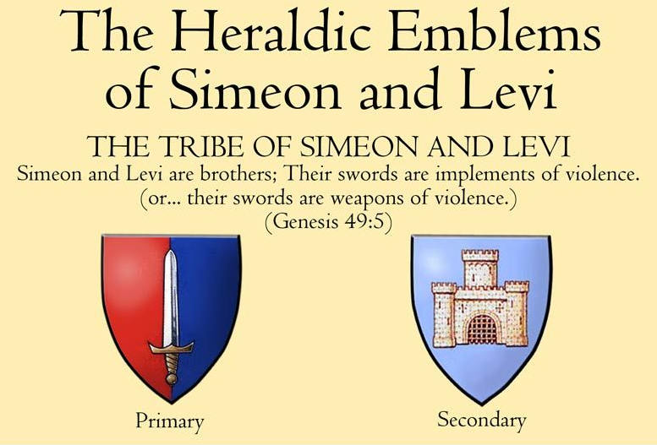

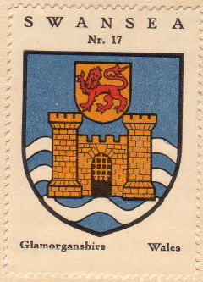
Swansea Coat of arms

Castles in Wales

Wikipedia: “This is a list of castles in Wales, sometimes called the "castle capital of the world" because of the large number of castles in a relatively small area. Wales had about 600 castles, of which over 100 are still standing, either as ruins or as restored buildings. The rest have returned to nature, and today consist of ditches, mounds, and earthworks, often in commanding positions. Many of the sites in Wales are cared for by Cadw, the Welsh government's historic environment service.”

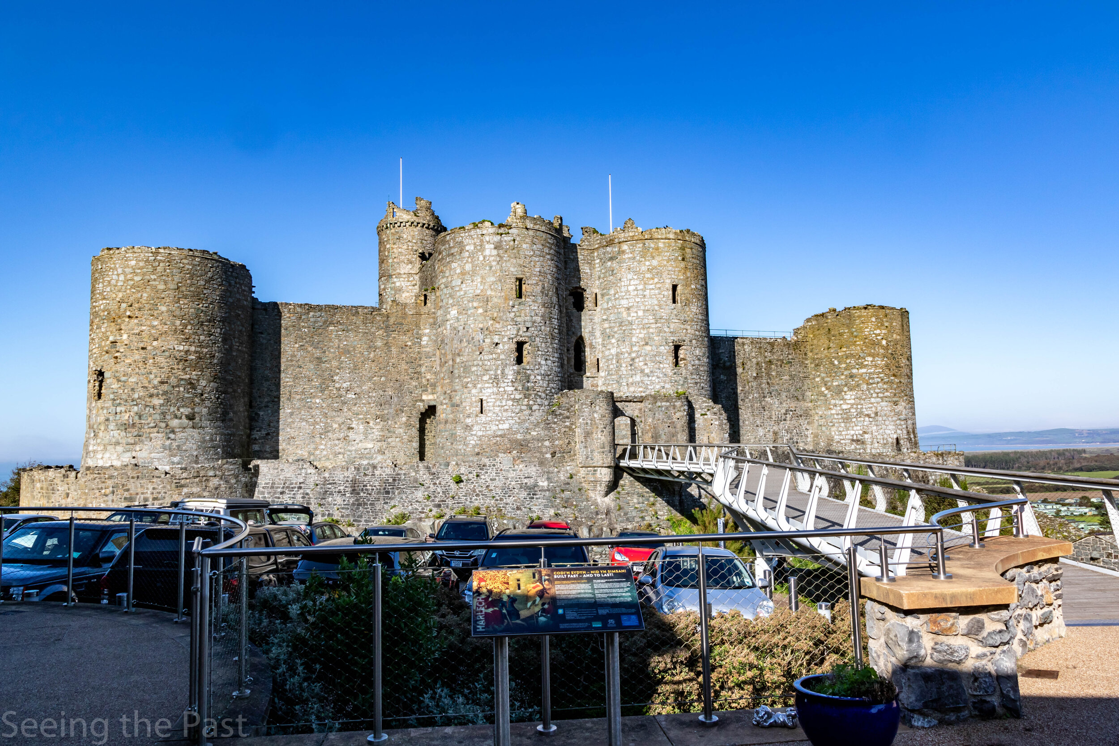
Harlech Castle, Wales

10th Clue: Levi: exiles & strangers

Examples of ‘golah, gelot, galah, galut, galim’ with the meaning of exile(s).

And he carried away Jehoiachin to Babylon; the king’s mother, the king’s wives, his officials, and the chief men of the land, he took into captivity <01473, גולה, golah> from Jerusalem to Babylon (2Kings 24:15).

And the Danites set up the graven image for themselves; and Jonathan the son of Gershom, son of Moses, and his sons were priests to the tribe of the Danites until the day of the captivity <01540, גלות, gelot> of the land (Judges 18:30).

"Thus says the LORD, the God of Israel: Like these good figs, so I will regard as good the exiles <01546, גלות, galut> from Judah, whom I have sent away from this place to the land of the Chaldeans (Jeremiah 24:5)

Therefore they shall now be the first of those to go into exile <01540, jiglu, יגלו><01540, galim, גלים>, and the revelry of those who stretch themselves shall pass away." (Amos 6:7).

So now they will go away prisoners <01540, jiglu, יגלו> with the first of those who are made prisoners <01540, galim, גלים>, and the loud cry of those who were stretched out will come to an end. (Amos 6:7, BBE).
Exiles – strangers

Exiles are by definition strangers. So it is remarkable that the meaning of Celts or Gauls is strangers.

Germanic W → Roman G

The W in Germanic often becomes a G or Gu in the Roman languages. Defending oneself (sich wehren) leads to 'wehrmacht'. With the 'wehrmacht' you get into a 'war', or 'la guerre'. In English, 'warden' is derived from the above words. A warden keeps watch in a building or department, and in traffic it is a 'traffic warden'. But in French it becomes 'la garde', which in turn produces 'guard' in English. A 'ward(en)' is therefore a 'guard', the first word came directly from Germanic and the second word came from Germanic via French.

Wales (English) → Pays de Galles (French)

Gauls in French are called Gaulois. The language in Ireland and Scotland is called Gaelic. And Wales is in French Pays de Galles. A word very close to 'galim' of Amos 6:7.

The Walloons in Wallonia are from the same family as the Welsh in Wales. The W and G are simply interchangeable.

Bert Otten
September 2022
Gouda, Holland

I’ve been wanting to write about Levi – Wales for 10 years now. I finally published this document in Dutch on the 28th August 2022, and now its translation on the18th September. In between these two dates the Prince of Wales became King Charles III and the next day, the 9th September 2022, he bestowed the title Prince of Wales to his son William. I find this coincidence encouraging.

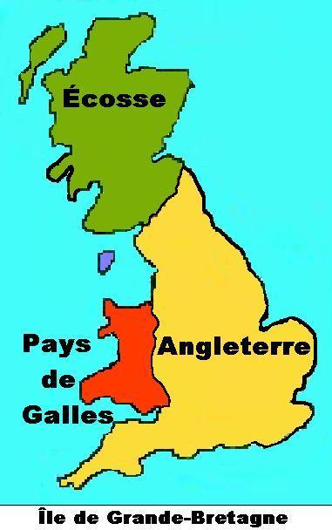

For more information about the other tribes:

https://sites.google.com/site/waarheidvrede/the-ten-lost-tribes

